EENG 385 - Electronic Devices and Circuits

Frequency Domain: Active Filters

How To: Use Simulator to Build a Bode Plot Using Point-by-Point method

**How To: Simulation Bode Plot – Point by Point**

Let’s construct the low pass in Figure 1 using MultiSim Live. The 5V DC supply for the op amp is an important detail copied over from the real Audio board filter.

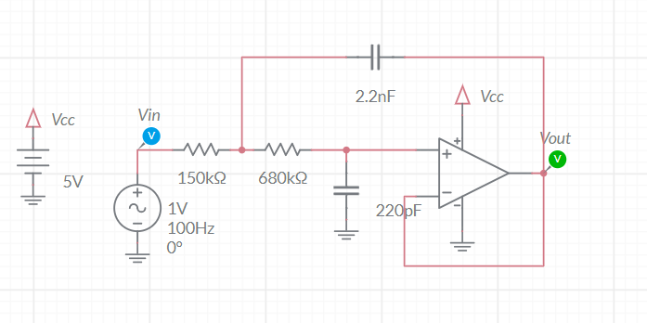

Figure : The low-pass filter on the Audio board is built around an op amp powered by 5V and gnd.

In case you forgot, here is the parts list from Multisim Live.

|  |  |  |
| --- | --- | --- |
| Component | Tool | Name |
| DC Voltage | Sources | DC Voltage |
| AC Voltage | Sources | AC Voltage |
| Ground | Schematic connectors | Ground |
| VCC | Schematic connectors | Connector |
| Resistor | Passive | Resistor |
| Capacitor | Passive | Capacitor |
| Op amp | Analog | 5 Terminal Opamp |

You will also need to put some probes on the input and output. Take a moment to change the labels of these probes to Vin and Vout. You can do this by double clicking on the probes and using the component properties pull-out to change the ID field. Once you have constructed and setup, let’s apply some sine waves and observe the behavior of our low-pass filter in the time domain.

The op amp in Figure 1 (and on your Audio board) is powered from a single rail, meaning 5V and 0V. This can cause problems for signals that have no DC bias. “No DC bias” means that the AC waveform is centered at 0V. As a reminder the raw audio input to your Audio board has no DC bias – it is about 1.0V peak-to-peak and centered at 0V.

Let’s see what the low-pass filter would do to an AC input with no DC bias. To do this, make the following changes to the AC source and simulation. To edit the AC source properties, double click on the source and edit the fields in the properties pull-out.

* AC Voltage Freq = 1000Hz VA = 0.5V VO = 0V
* Simulation End Time = 4ms

Run the simulation by pressing the play button on the top menu bar. View the output by clicking on the Grapher or Split buttons in the top menu bar. With no DC bias applied to the input AC source, is the output of the low-pass filter an accurate reproduction of the input? No.

Since the output of the filter is being clipped, we need to provide a DC bias to the AC input so that the 1V peak-to-peak input it is centered at 2.5V. To do this make the following changes to the AC source.

* AC Voltage Freq = 1000Hz VA = 0.5V VO = 2.5V
* Simulation End Time = 4ms

Re-run the simulation by pressing the play button on the top menu bar. Now you should see that the output is a complete sinusoid like that in Figure 2.

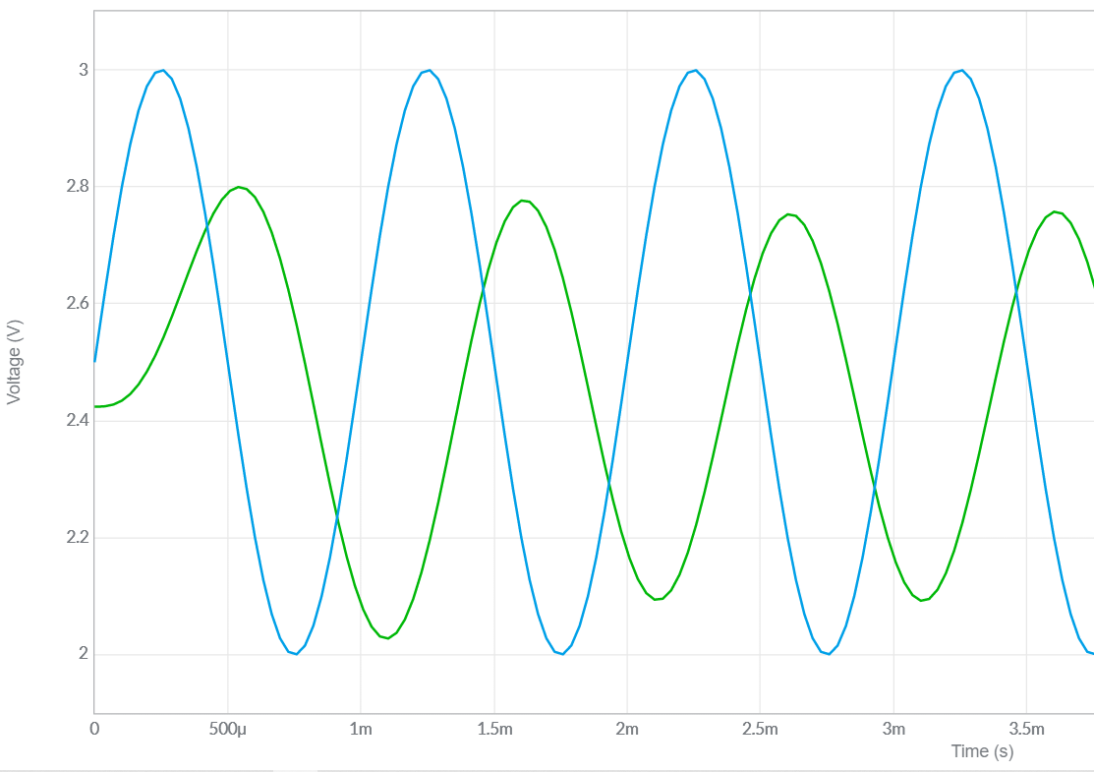

Figure : A 1,000Hz input waveform (in blue) and the output(green) from the low-pass filter.

From this graph, you should be able to see that the output waveform has a lower amplitude than the input. This change in amplitude, from input to output, is called attenuation. Mathematically, attenuation is the ratio of the output over the input. You will form this ration to normalize the output amplitude in terms of the input amplitude. Since we will be measuring very large ranges of attenuation, you will measure attenuation in units of decibels by using the following equation.

$$attenuation in decibels=20*log{({V_{out}}/{V_{in}})}$$

Let’s measure the attention in decibles of the waveforms in Figure 2. Using the y-axis cursors in Grapher tab of the MultiSim simulation, I measured:

* The input waveform to be 1.00V peak-to-peak
* The output waveform to be 0.75V peak-to-peak

Thus at 1,000 Hz, the low-pass filter has 20*log(0.75/1.0) = -3.1dB of attenuation.

In addition to the change in the amplitude, the output waveform (green in Figure 2) is shifted to the right of the input. This shift in time is called phase delay. Phase delay is measured in degrees that the output waveform occurs with respect to the input waveform. Let’s measure the phase delay of the output in Figure 2. Start by choosing any peak of the input; I’ll choose the peak at 2.25ms. Now look for the peak in the output that immediately follows the input. This occurs at 2.6ms. To find the phase angle, divide the time different between these two peak by the period of the waveform; (2.25ms – 2.6ms)/1ms = -0.35. Finally, multiply this value by 360° to get the phase delay; -0.35*360° = -126°.

So at 1,000Hz the low pass filter in Figure 1 has -3dB of attenuation and -126° of phase shift. A Bode plot is a pair of graphs describing the attenuation and phase shift of a circuit as a function of frequency. You can build a Bode plot by repeating the calculations in the previous paragraph multiple time. So let’s give it a try.

Start by downloading and opening the filterWorkSheet posted on the Canvas page. Go to the LPFsim tab and fill in value for Vout/Vin for 1000Hz row and enter the ratio of the output over the input; 0.75 in cell C9. The corresponding decibel entry will autopopulate in the Attenuation column. Next enter the time delay between the peaks of the input and output waveforms in units of milliseconds in the Delta (ms) column; -0.35 in cell E9. The corresponding Phase entry will auto-populate in the Phase column.

Now change the frequency of the input waveform in MultiSim to every frequency value in column B that is not already filled in. Some technical notes:

* When you get to higher frequencies, the amplitude of the output waveform will be so small that it becomes hard to measure. When this happens zoom on the vertical axis by scrolling the center mouse wheel on the vertical axis.
* You can grab and slide the vertical axis to center it while zooming.
* The output waveform will not stay centered at 1.0V. You should determine the amplitude using a single the highest and lowest points over a single wavelength. Do you best.
* To measure the phase, I left one x-axis cursor at a peak of the input and then zoomed in on the vertical axis until I could move the other x-axis cursor to the an output peak.

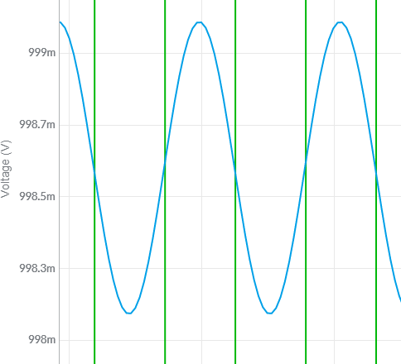

I’d like to take a moment and draw your attention to the frequencies you used as the input frequencies and listed in column B of the spreadsheet. Note that these frequencies follow a pattern of 1.0, 2.2, 4.7 before repeating at the next power of 10. As an electrical engineer you would say that we have 3 different frequencies per decade. These 3 frequencies are separated by a multiplicative factor of $\sqrt[3]{10}=2.15 ≈2.2$. When you plot numbers whose x values are separated by a multiplicative factor of 2.15 on a logarithmic horizontal axis the points appear equally separated along the axis. This is a result of the fact that $\log\left({2.15}^{n}\right)=n*log⁡(2.15)$. So in short, using a geometric factor to increase frequencies ensures the points are space equally along a logarithmic axis. Neat huh?

You can usually copy graphs from Excel and paste them into Word. At worst you can use the windows snipping tool to make a copy of your Bode plot. Try to make the graph reasonably large so that the graders can read the units in the horizontal and vertical axis’.

Now that you have a solid understanding of how a low-pass filter operates, let’s simplify the process of building a Bode plot.